Project Development phase Sprint-2

|  |  |
| --- | --- |
| Date | 29 October 2022 |
| Team ID | PNT2022TMID33510 |
| Project Name | AI BASED DISCOURSE FOR BAKING INDUSTRY |

Screenshots of Sprint 2:

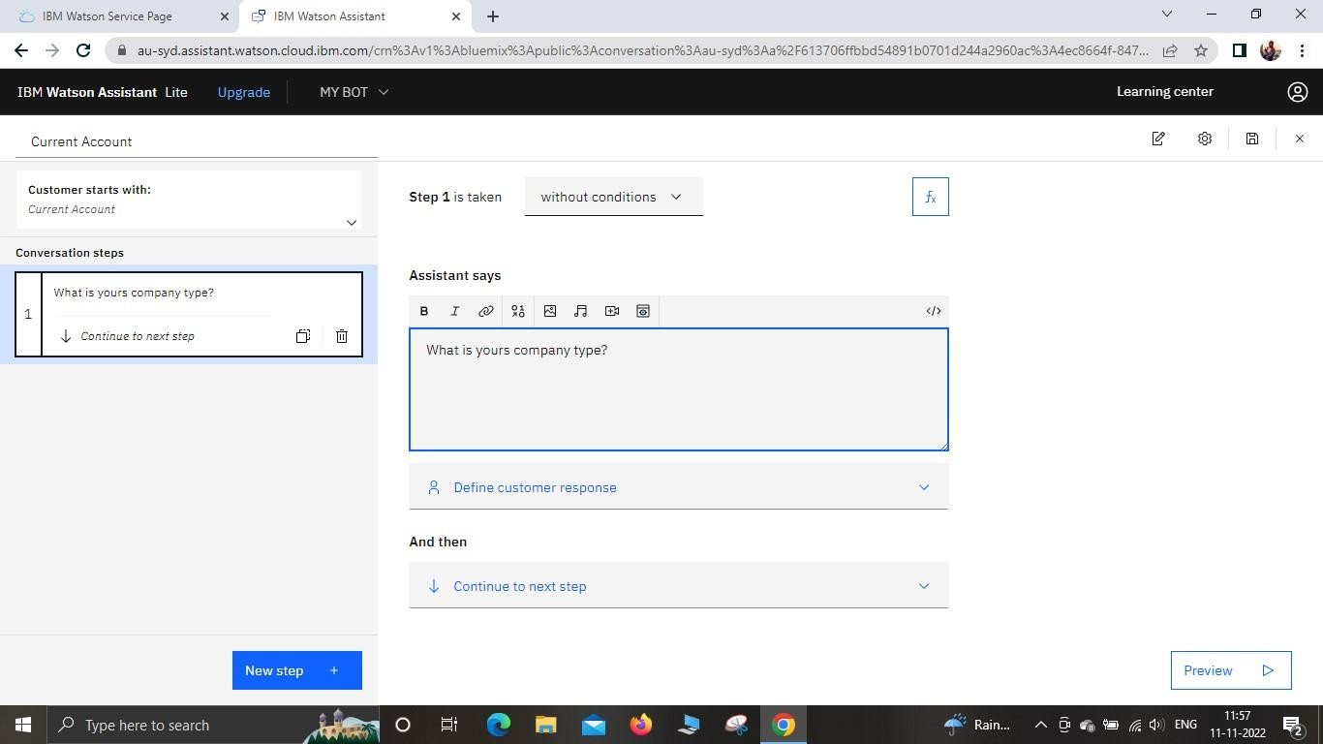Creating Current Account Action:

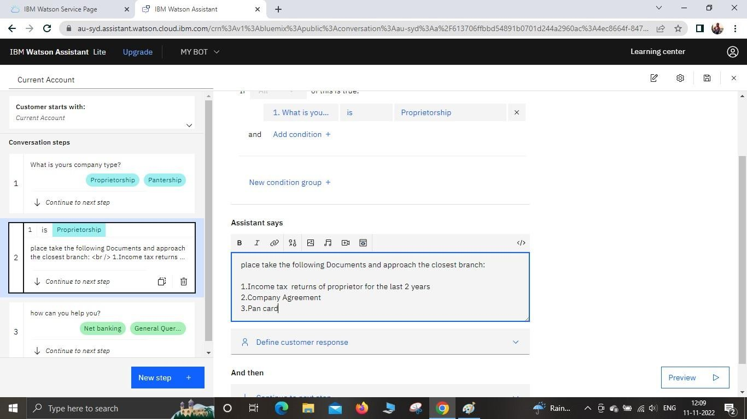

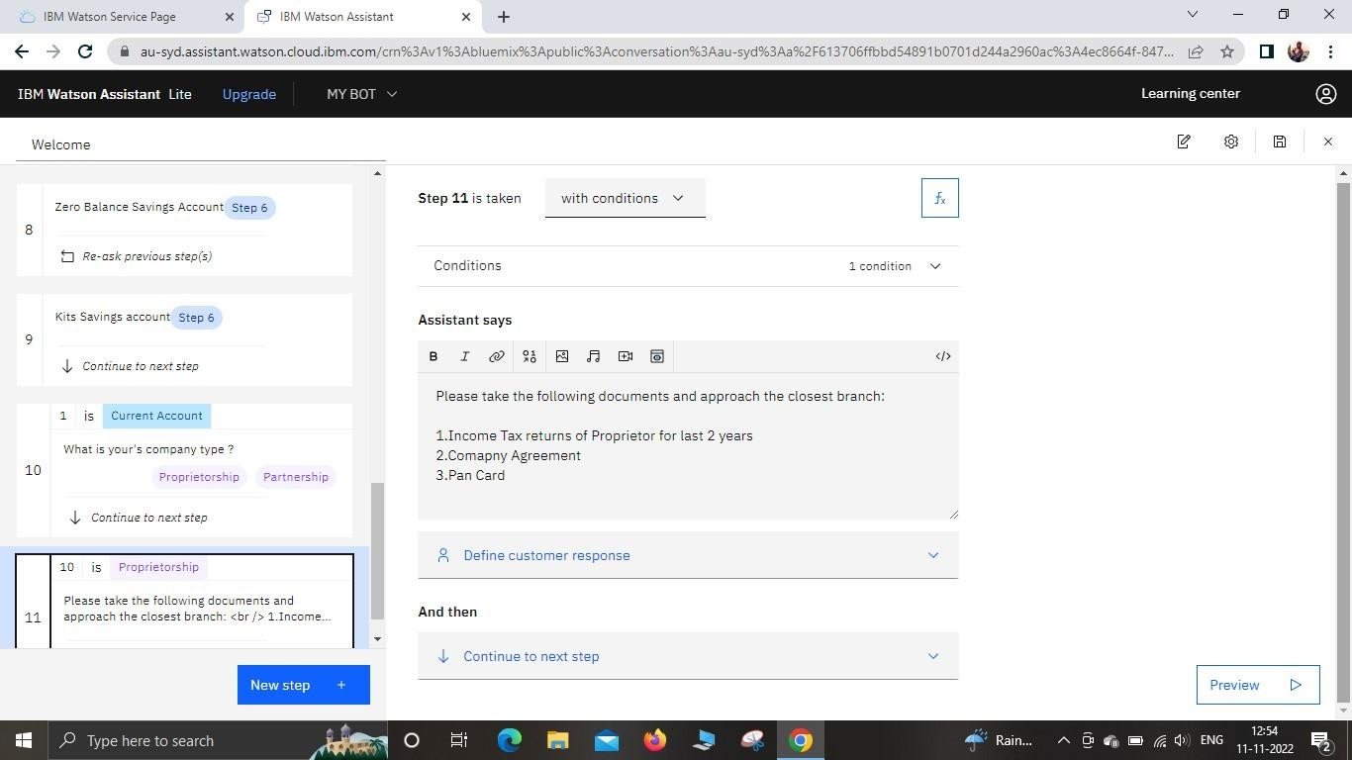

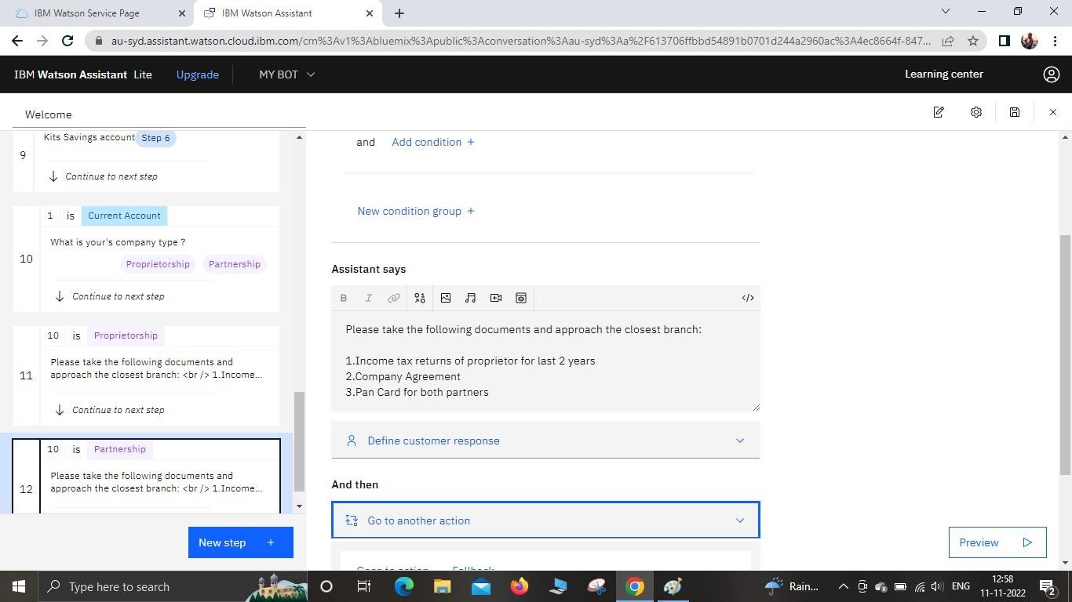

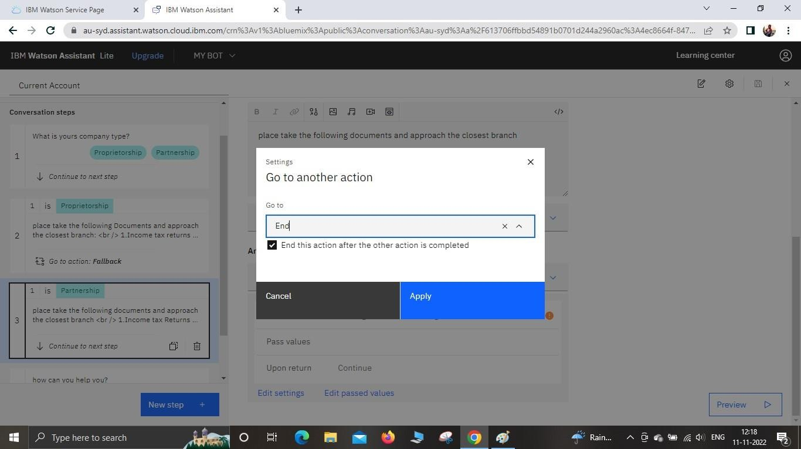

Creating the Loan Account Action:

